Aeolus Mechanical Design Induction 2026 Round – 2

Name: Marmik Shah
Student ID: 2026A4PS07
BITS email: f20260775@hyderabad.bits-pilani.ac.in
Github repository: https://github.com/shahmarmik/Marmik-Shah_2026A4PS0775H_Mechanical-Design
Google Drive:
Submission Date: 10th Sep. 2026

- What are the four basic forces acting on an aircraft, and how do they affect its flight?
Answer:
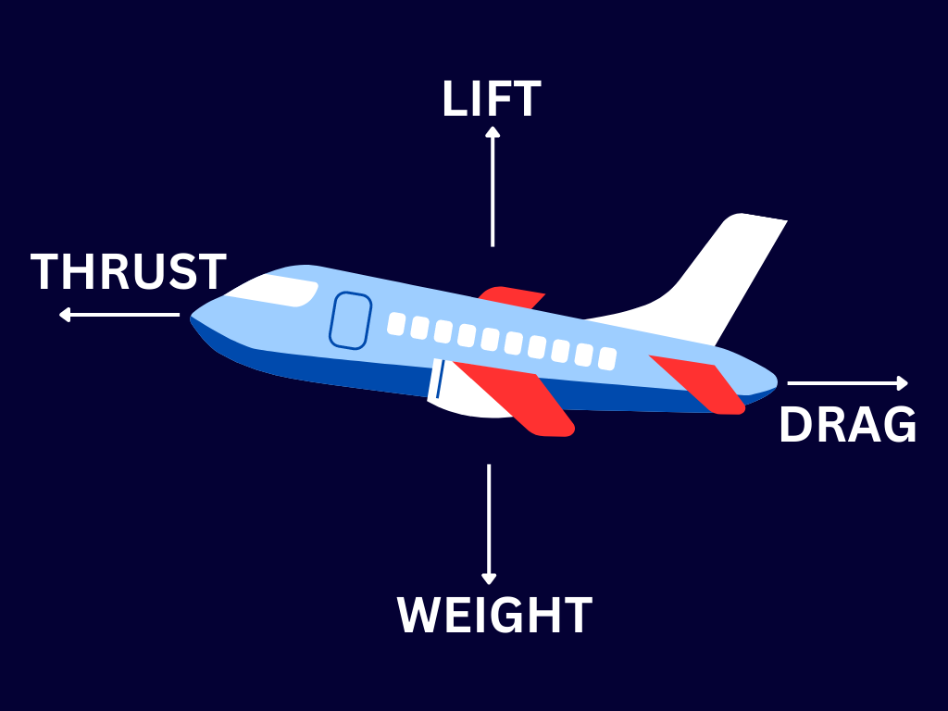
The four basic forces acting on an aircraft are Thrust, Lift, Weight and Drag. Each of their effects are as follows:
- Thrust: The force which is produced by the Aircraft engine to move it in the forward direction.
- Drag: The air resistance which acts backward opposing the forward movement of the aircraft is called drag
- Weight: The force which pulls the aircraft downwards towards the earth
- Lift: The aerodynamic forces which acts upwards and generated by the design of the wings.
The aircraft ascends when Lift > Weight, if Lift < Weight Aircraft descends. In case Lift = Weight, aircraft remains at the same altitude.
Similarly, the aircraft accelerate when thrust > drag, it decelerates when thrust < drag.

- What is meant by stall speed? What happens to the airflow over a wing as an aircraft approaches a stall?
Answer:
The stall speed is the minimum speed at which the Aircraft can maintain controlled flight without stalling.
As aircraft approaches the stall, at an increased angle of attack the air flow separates from the wing’s top surface at the rear end of the wing. This creates turbulent air flow above the wing resulting in decreased lift.

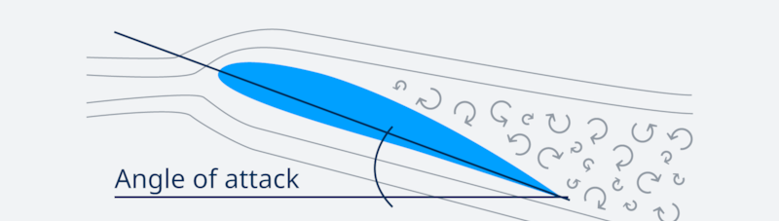
At the critical angle of attack (above 20 deg), the airflow can no longer remain attached to the wing. Flow separation from the wing increases rapidly, causing a sudden reduction in lift. The aircraft then stalls, and the nose may drop as the wing loses lift.

- Two identical drones have the same motors and batteries, but one weighs significantly more. Will simply increasing the throttle make their flight performance the same?
Answer:
By simply increasing the throttle of the heavier drone, its flight performance cannot be made similar to the lighter drone for the following reasons:
- Heavier drone requires more lift to ascend and more thrust to hover or move forward. As both drones are having similar motors and batteries, heavier drone will drain battery faster for the same flight
- Heavier drone will have relatively less thrust compare to lighter drone
- The flight duration for the heavier drone will be shorter compare to lighter drone for the similar batteries as heavier drone consumes more power by increased throttle
So, throttle can compensate for additional weight to a limited extent, but it cannot make two differently weighted drones perform identically when they have similar motors and batteries.

- A quadcopter is perfectly balanced and hovering. One motor suddenly becomes slightly weaker than the others. Besides losing altitude, what other effect could this have on the drone’s motion?
Answer:
- As one motor becomes weaker, it will produce less thrust, which will create imbalance in lift. The quadcopter will pitch or roll towards the side of weaker motor resulting in sideway drift.
- To manage the spin in quadcopter, diagonally opposite motors spin in the same direction (two clock-wise and two counter clock wise) to cancel the spin. If one motor suddenly becomes slightly weaker, the pair of motors rotating in opposite direction will create dominant spinning force. The entire body of the drone will spin (yaw) in the opposite direction of the dominant motors' rotation.

- What is the difference between Finite Element Analysis and Computational Fluid Dynamics Analysis. How does each one help?
Answer:
 | Finite Element Analysis (FEA) | Computational Fluid Dynamics (CFD)
Analysis | Structures and Thermal | Fluid flow
Scope | To study, how structure responds to forces, loads, heat, or vibration | To study air / other fluids flow around/inside object, heat transfer with fluid flow
Result | Stress, strain, deformation, vibration, and structural strength | Lift, drag, pressure distribution, airflow separation, and aerodynamic performance
Example | Can a drone arm withstand the motor's thrust without breaking? | How much lift and drag does a drone's wing produce?
Popular Tools | Ansys, Abaqus, MSC Nastran etc. | Ansys Fluent

FEA: The structure is divided into many small elements, and the computer calculates how each element behaves under applied loads.
It helps in finding out regions with higher stress, structural strength, to optimize structure weight etc.
CFD: The fluid region around an object is divided into many small computational cells, and the computer solves equations describing fluid motion.
It helps to understand airflow behaviour, improves aerodynamic efficiency, increase lift etc.

